ng new CustomDirectivesExample

ng g directive apphighlight

apphighlight.directive.ts

import { Directive,ElementRef } from '@angular/core';

@Directive({

  selector: '[apphighlight]'

})

export class ApphighlightDirective {

  constructor(el:ElementRef) {

    el.nativeElement.style.backgroundcolor='yellow';

   }

}

App.component.html

<p apphightlight> Highlight Me</p>

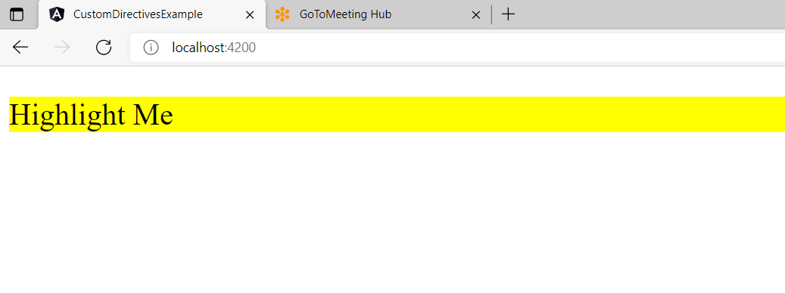

Handling user events

import { Directive,ElementRef,HostListener } from '@angular/core';

@Directive({

  selector: '[apphighlight]'

})

export class ApphighlightDirective {

  constructor(private el:ElementRef){

  }

   private highlight(color:string)

   {

     this.el.nativeElement.style.backgroundColor=color;

   }

   @HostListener('mouseenter') onMouseEnter(){

     this.highlight('yellow');

   }

@HostListener('mouseleave') onMouseLeave(){

  this.highlight('');

}

}

